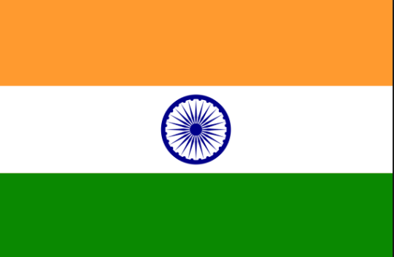

Dear parent/ Carer,
Welcome back to Shortlanesend School. I hope you have all had a fantastic, relaxing and fun-filled summer break.
For the first half term we will be focusing on helping the class to settle into the class and school routines. Encouraging them to form new friendships and positive relationships with staff. We will spend lots of this time focusing on children’s interests and encouraging the start of a positive learning journey.
After half term, Class ONE will be travelling to India. During this time I will be looking at different modes of transport in the world. We will look at some world maps and compare similarities and differences between India and England. We will look at different modes of transport to travel across the world and where different countries are on a world map.
We will be getting creative. We will be making a variety of Indian dishes, making colourful Rangoli patterns and creating Divi lamps from clay.
We will also be putting on a very special Christmas performance at the end of term on the 14th December.
PE will be on Tuesdays and Thursday. Can all children bring their kits in for the entire week.
As always, please come and see us if you have any questions,
Kind regards,
Mrs knight

Our focuses for this term for year one are:
Year 1: Writing - composition
write sentences by:
Saying out loud what they are going to write about.
Composing a sentence orally before writing it.
Sequencing sentences to form short narratives.
Writing - vocabulary, grammar and punctuation
beginning to punctuate sentences using a capital letter and a full stop, question mark or exclamation mark.
leaving spaces between words.
Joining words and joining clauses using ‘and’.

Mathematics
In Maths this term we will we be covering the following units.
We will teach maths through mastery using fluency, reasoning and problem solving.
Year 1
Number place value and rounding
Measurement: Long/short/taller/shorter
Addition and Subtraction
Measurement: Days of the week and Months of the year.
Geometry: properties of shapes
Geometry: position and direction

