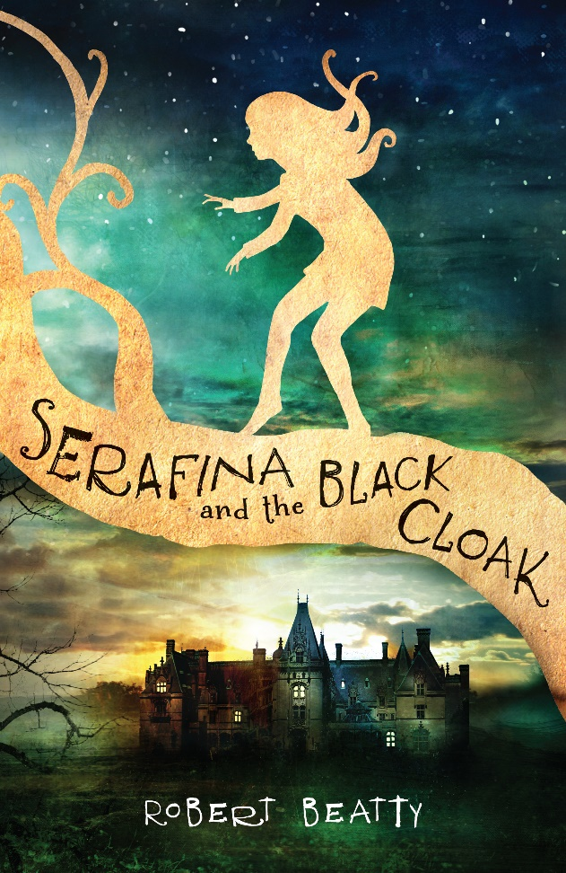
Dear Parent, Carer,
Welcome back and a Happy New Year to you all.
This terms topic is ‘Lost in a book’ which immerses Class 4 into the world of Serafina-a girl who lives secretly with her father in the basement of Americas largest house, The Biltmore Estate. Serafina is a brave and curious girl and when children start disappearing in the estate, she knows who the culprit is-a terrifying man in a black cloak who stalks the corridors at night!
It is a wonderful book that I am sure the children will enjoy tremendously, and all our writing, art and topic work will be focused upon it, including the amazing Biltmore Estate-its history and its creation by George Vanderbilt.
In geography we will be researching the USA; its states, capitals and human and physical features, including North Carolina, home of the Biltmore Estate
PE will once again be on a Tuesday and a Friday, and can I please reinforce the need for all children to have their PE kits in school for these days.
In PSHE we will be looking at ‘belonging, resourcefulness and resilience’ and in RE we will be focusing on the parables of Jesus: Why are Jesus’ parables important to Christians?
As ever, if require any further information, please do not hesitate to contact me,
Kind regards,
Mr Easter

