THE CARIBBEAN
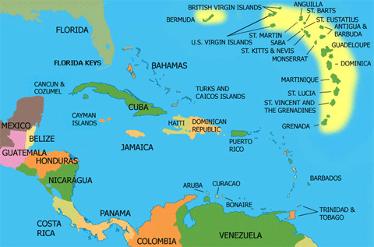

Welcome back! I hope you have all had a fantastic summer break and looking forward to another adventure in school.
This term, Class 4 are travelling to the Caribbean islands, learning about the islands geography (physical and political), history (including colonialism, slavery and the influences this has had on the modern-day Caribbean culture and identity), sport (cricket, athletics and bobsleigh) and what makes these islands truly special places.
We will be immersing our Caribbean adventure alongside and through our other learning.
In maths we will be learning more about place value (numbers up to 1,000,000), addition and subtraction (up to and above 4 digits), multiplication and division, shape and fractions.
In English the children will be writing non-chronological reports on some of the Caribbean islands, poetry based on Caribbean culture, instructions focused around cooking some traditional Caribbean cuisine and short stories based around colonialism and slavery.
Science is all about living things and their habitats with special emphasis on Caribbean animals, although we are hoping to visit the wildlife trust and do some pond dipping soon, something to wet the children’s enthusiasm!
PE will be focused around dance, with a Caribbean twist, surfing (year 5’s who can swim 25 metres or more) and swimming for everyone else. Year 5’s will also be participating in tag rugby sessions on Friday afternoon which are being run by the Cornish Pirates through the school’s sports premium funding.
In art the children will be learning about different techniques, for example pointillism, used in painting and will be trying their new skills on a variety of different mediums.
RE will focus on Hinduism (How do Hindus express their faith and what does this tell us about their values?) and Christianity (Creeds – What do Christians believe about Jesus?).
.
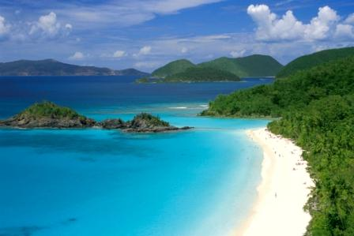
This Photo by Unknown Author is licensed under CC BY-SA-NC
Dates for your diaries;
15th October 2018………..Class assembly 2:15pm onwards
5th December 2018………Swimming gala 1:30pm-2:30pm

As always, if you require any further information or need to speak to me about anything, please pop in and see me or make an appointment through the office.
Thank you for your continued support,
Kind regards,
Mr M Easter

